http://www.guru99.com/keyboard-mouse-events-files-webdriver.html
You can build a series of actions using the Action and Actions classes. Just remember to close the series with the build() method
If there is only one action, there is no need to use build() method
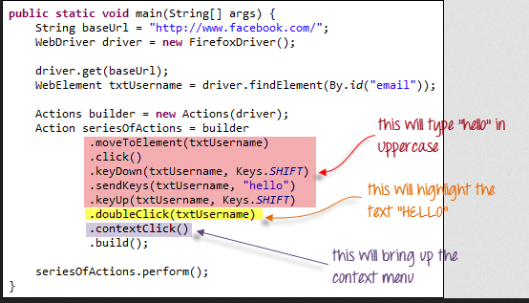

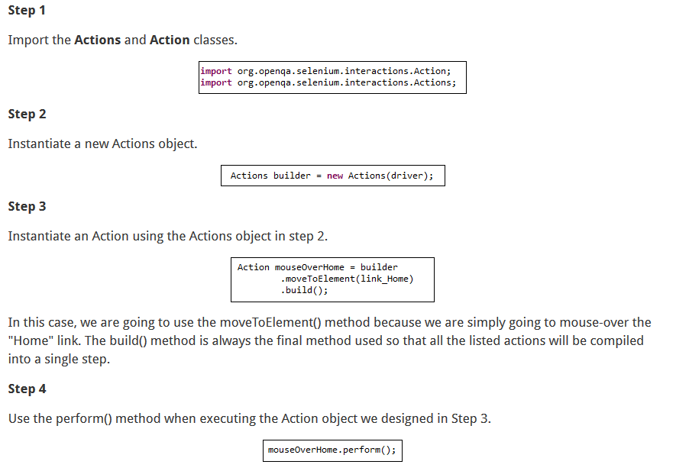

If build() method does not work, we should use below way:

Actions actions = new Actions(firefox);
actions.moveToElement(firefox.findElement(By.xpath("html/body/div[1]/div/div/div/ul[1]/li[2]/a")));
actions.moveToElement(firefox.findElement(By.xpath("html/body/div[1]/div/div/div/ul[1]/li[2]/ul/li[4]/a")));
actions.click(firefox.findElement(By.xpath("html/body/div[1]/div/div/div/ul[1]/li[2]/ul/li[4]/ul/li[1]/a")));

actions.perform();

